Chapter 3 Mini Case 2 (Assignment 3)

Mini Case 4 (MC4 Snooty Fashions)

# Relational Schema

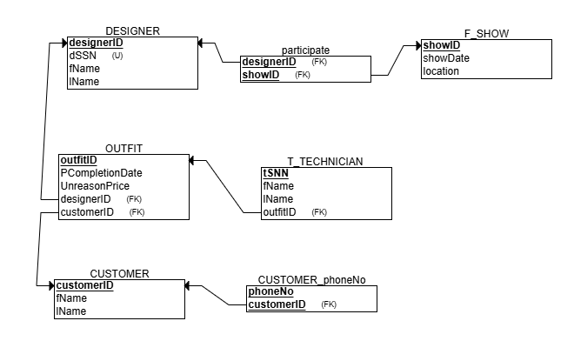

# ER Diagram (Chapter 2)

